State scholarship BRD-219

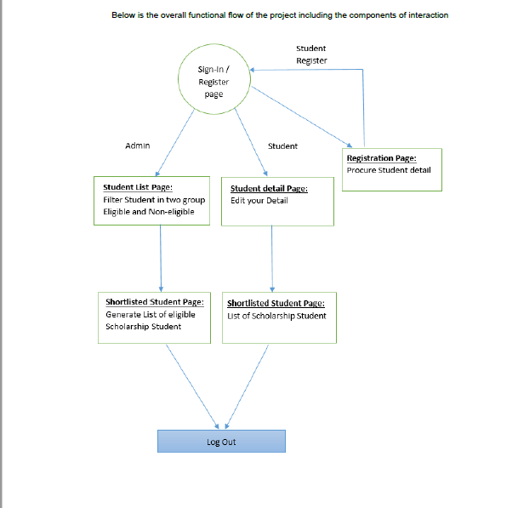

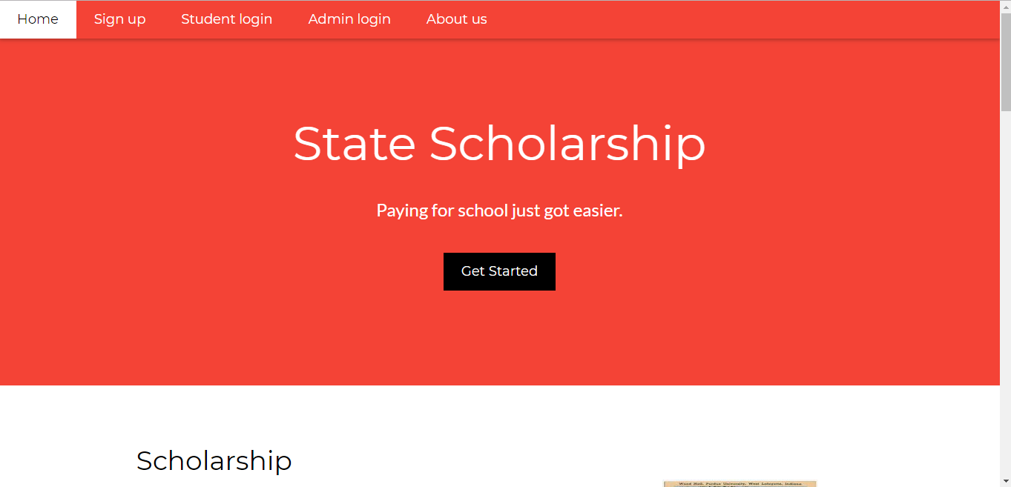

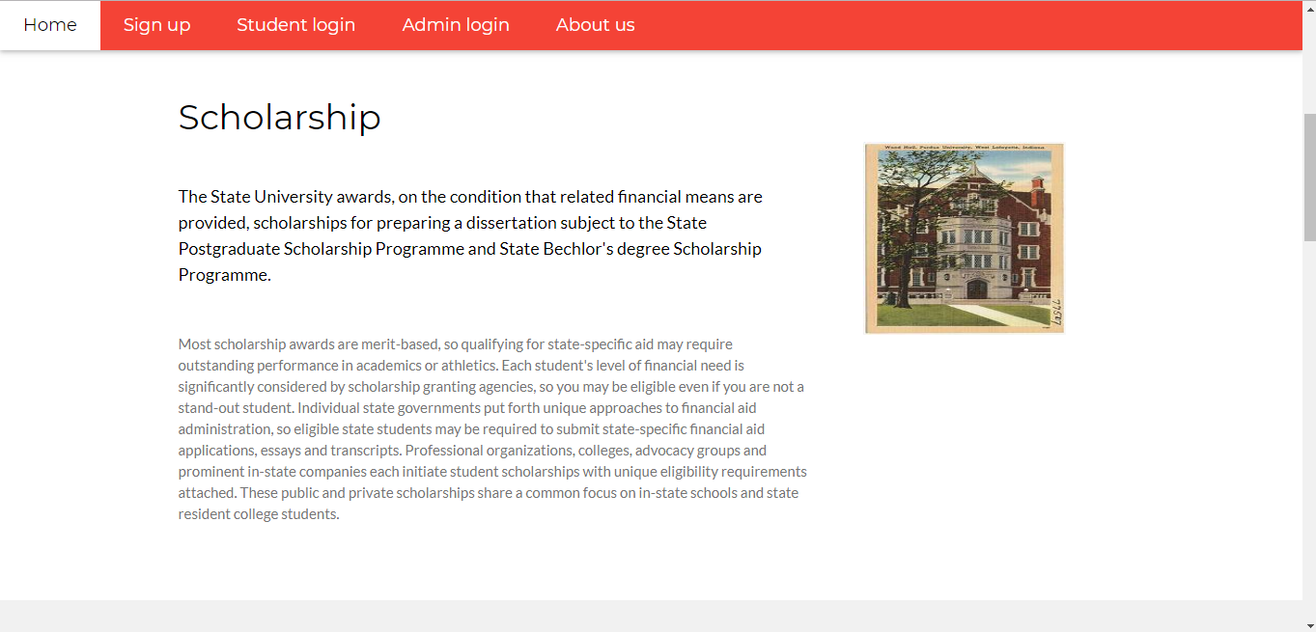

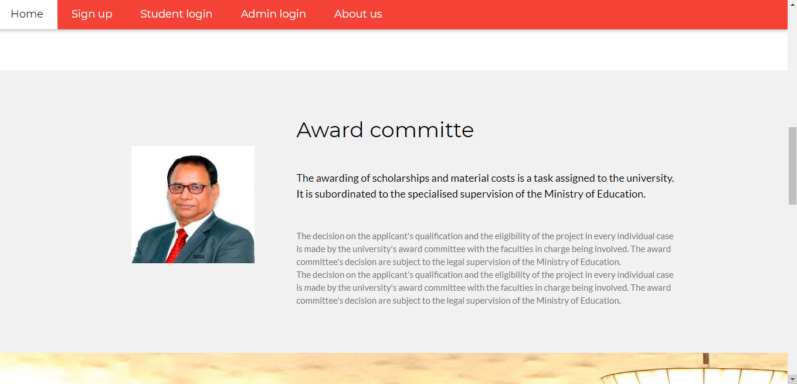

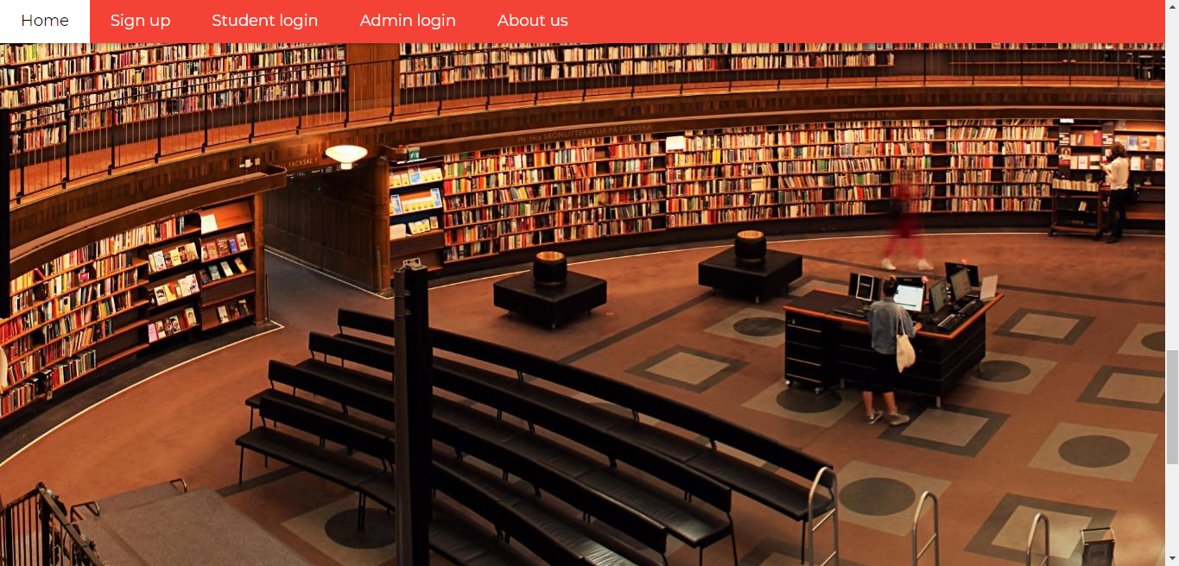

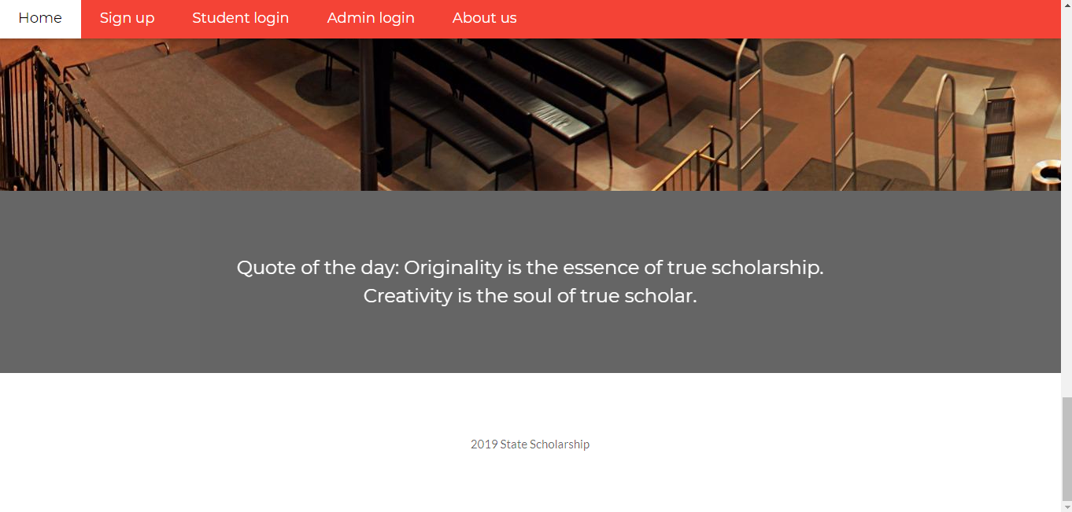

* Home
* Signup - Redirects to student signup page.
* Student login - Redirects to Student login page for those who are already registered.
* Admin login - Redirects to Admin login page.
* About us – Redirect to Info about scholarship website and contact details.

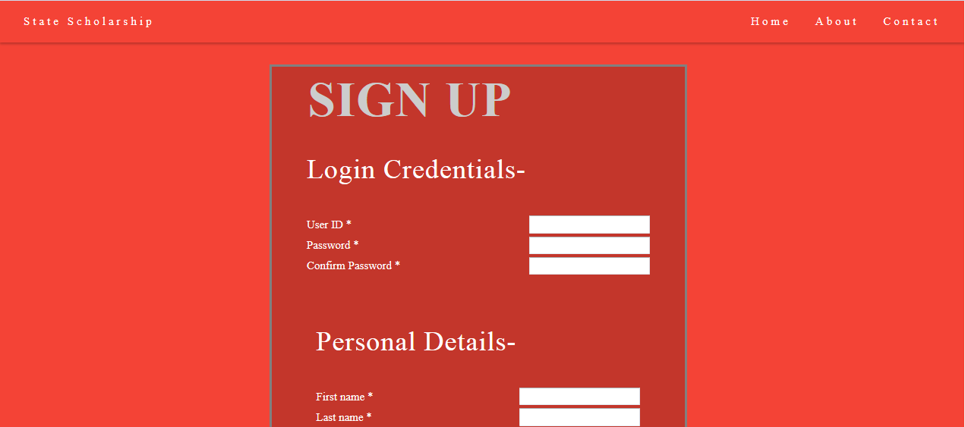

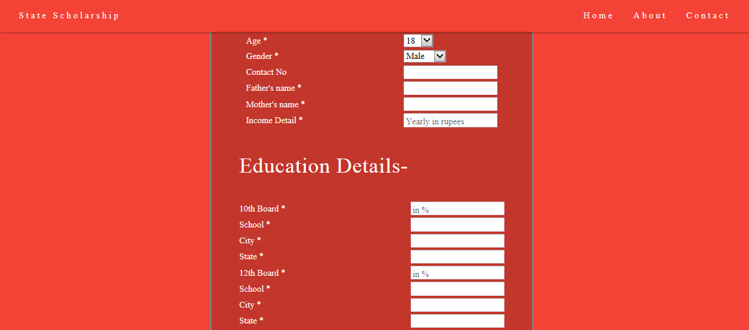

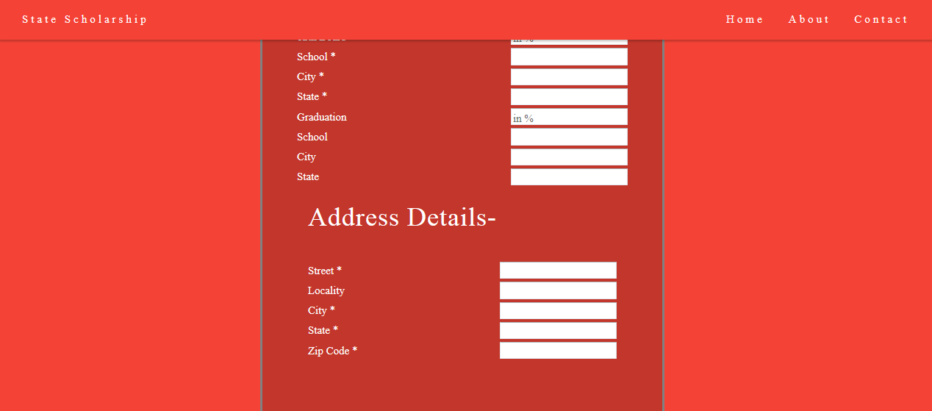

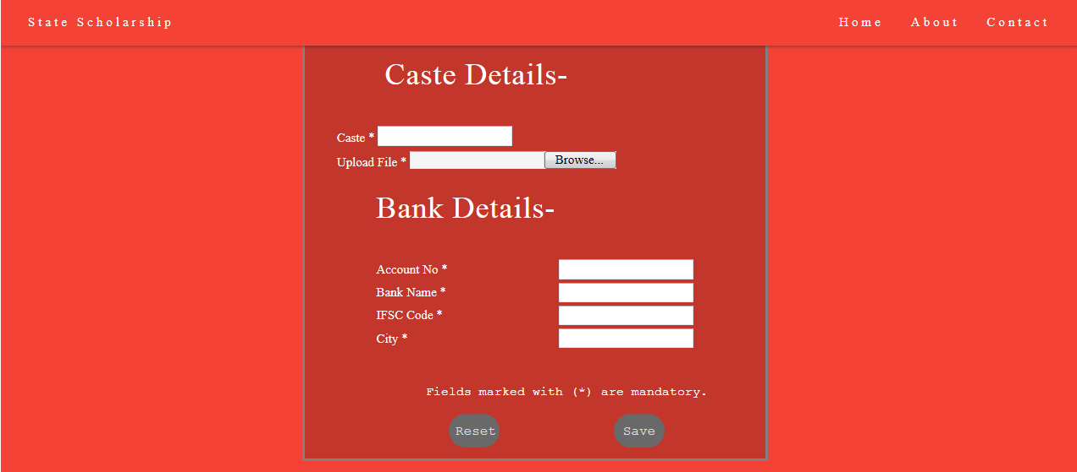

* Signup – Page for new Student registration.
* Home – Redirects back to Home page.
* About – Redirect to Info about scholarship website.
* Contact – Redirect to contact details.

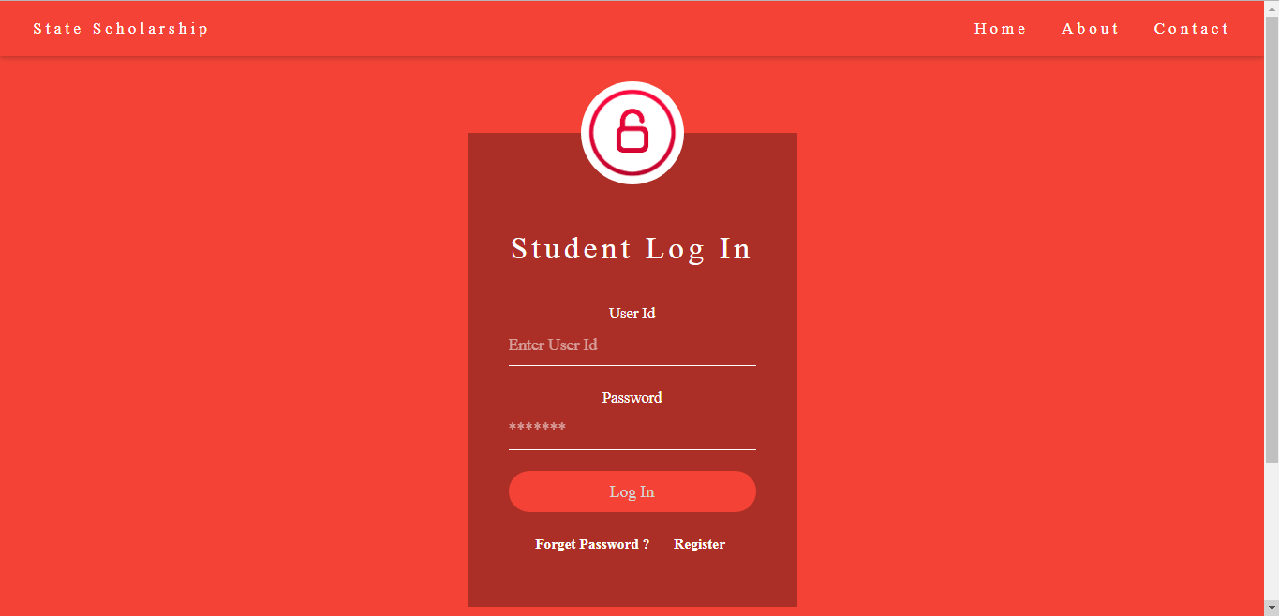

* Student Login – Login for registered students
* Home – Redirects back to Home page.
* About – Redirect to Info about scholarship website.
* Contact – Redirect to contact details.
* Forgot password – Here admin will be redirected to forget password page, where he can change his password using his user id.

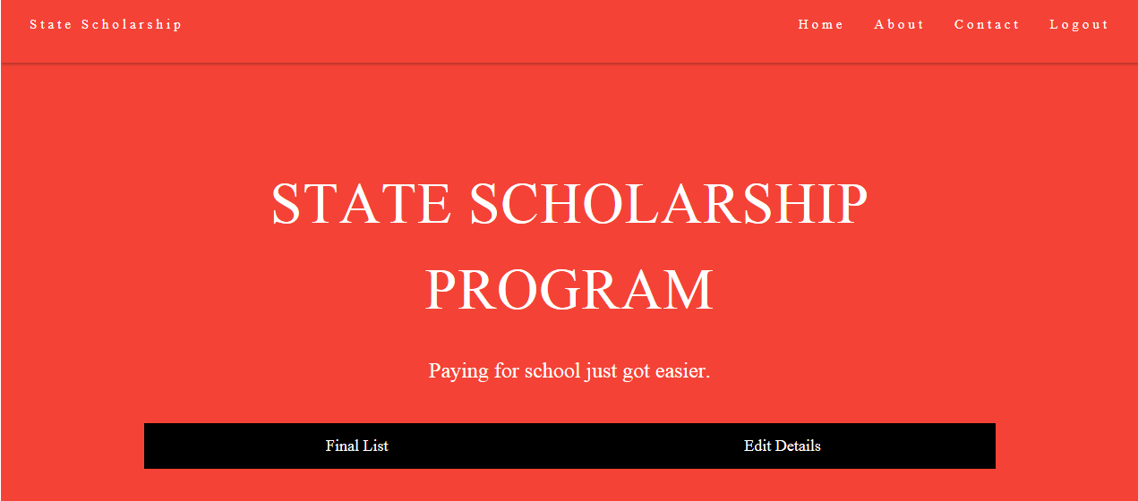

* Student home – After student log’s in, enters this page and it shows following options.
* Home – Redirects back to student Home page.
* About – Redirect to Info about scholarship website.
* Contact – Redirect to contact details
* Logout – It expires student login session and brings him back to student login page.
* Edit details – Here student will be directed to the edit details page which enable them to edit details they entered during registration.
* Final list – Here student will be directed to the final list page where he/she can view the approved student for scholarship.

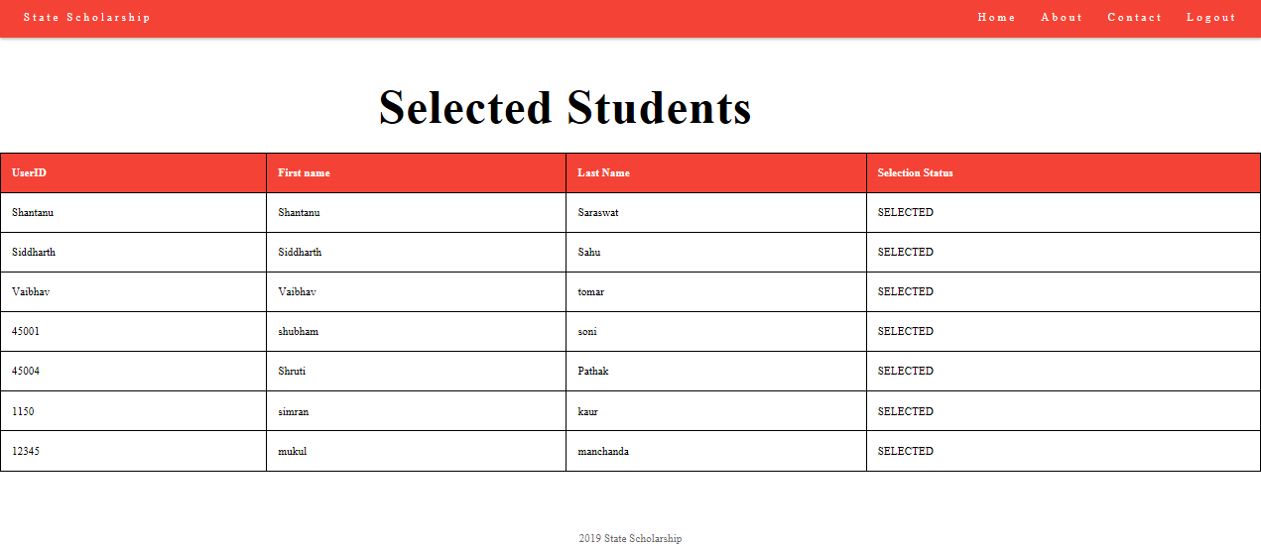

* Selected student – It shows the status of scholarship approval.
* Home – Redirect students to their respective student login home.
* About – Redirect to Info about scholarship website.
* Contact – Redirect to contact details
* Logout – It expires student login session and brings him back to student login page

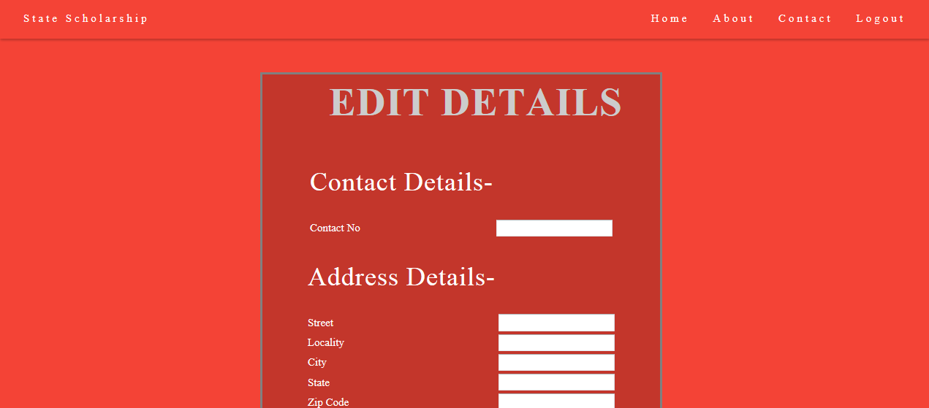

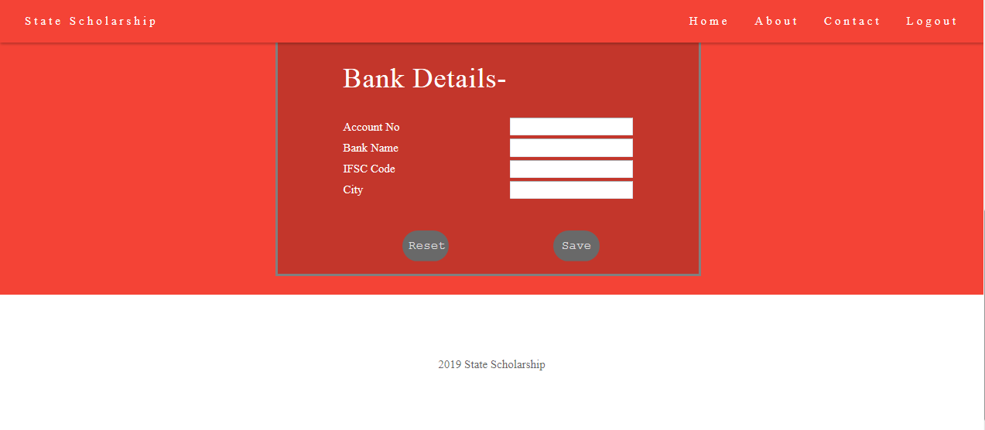

* Edit details – It is the page where student can edit the entered details, entered at the time of registration.
* Home – Redirect students to their respective student login home.
* About – Redirect to Info about scholarship website.
* Contact – Redirect to contact details
* Logout – It expires student login session and brings him back to student login page

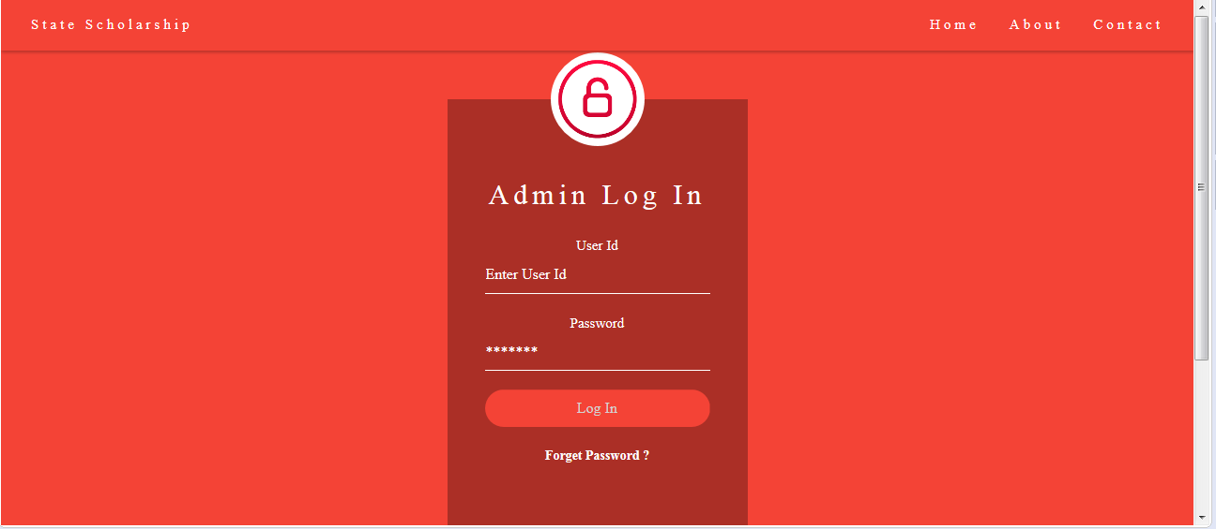

* Admin Login – Login for Admin.
* Home – Redirects back to Admin Home page.
* About – Redirects to Info about scholarship website.
* Contact – Redirects to contact details.
* Forgot password – Here admin will be redirected to forget password page, where he can change his password using his user id.

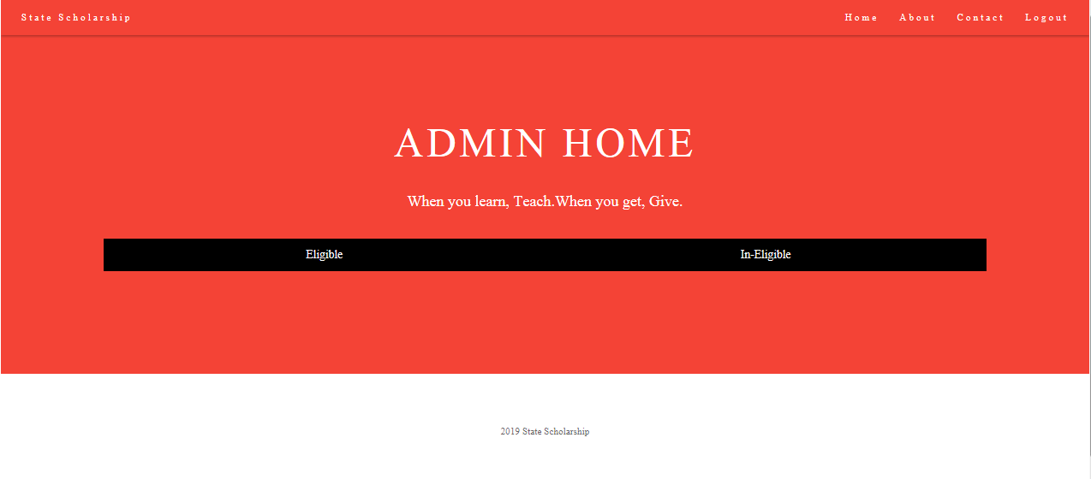

* Admin home – After Admin log’s in, enters this page and it shows following options.
* Home – Redirects back to Admin Home page.
* About – Redirect to Info about scholarship website.
* Contact – Redirect to contact details
* Logout – It expires student login session and brings him back to Admin login page.
* Eligible – Here Admin will be redirected to eligible page where he/she can view all the eligible students and can approve the scholarship by clicking the check box.
* In-eligible – Here admin will be redirected to in-eligible page where he/she can view In-eligible students.

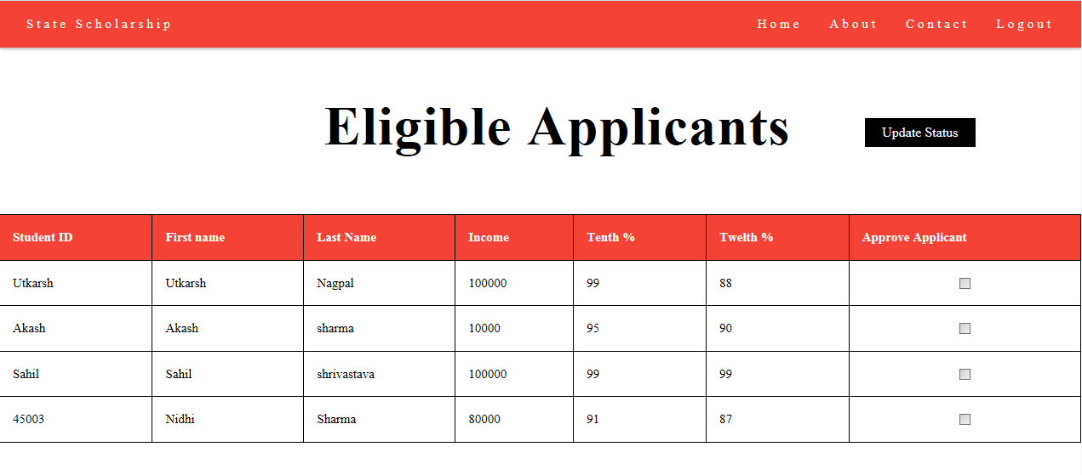

* Eligible-applicants – Here Admin can view all the eligible students along with there details and can approve the scholarship by clicking the check box.
* Update status – It update the table and redirects admin to selected student page where he can view selected student.
* Home – Redirects back to Admin Home page.
* About – Redirect to Info about scholarship website.
* Contact – Redirect to contact details
* Logout – It expires student login session and brings him back to Admin login page.

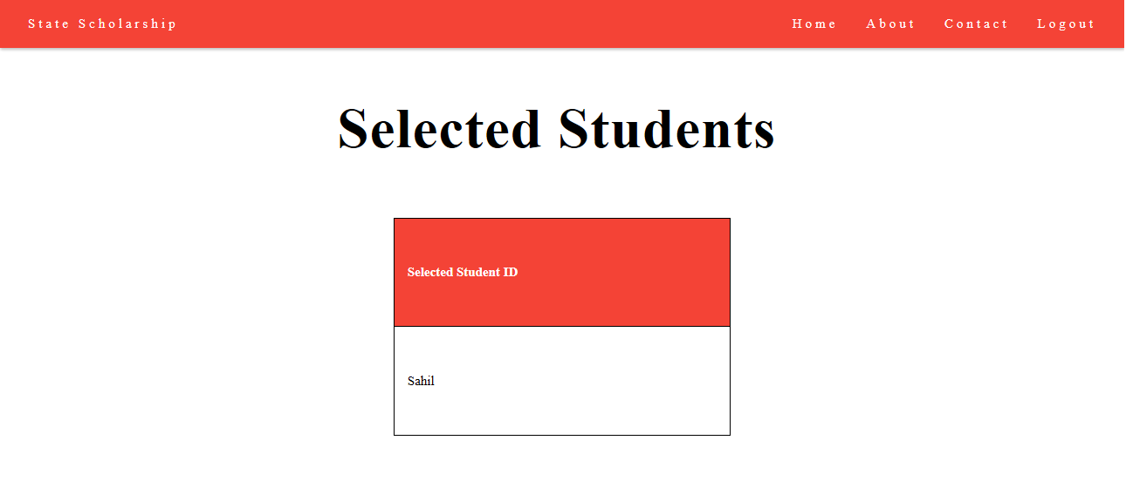

* Home – Redirects back to Admin Home page.
* About – Redirect to Info about scholarship website.
* Contact – Redirect to contact details
* Logout – It expires student login session and brings him back to Admin login page.
* Selected student – admin can view selected students.

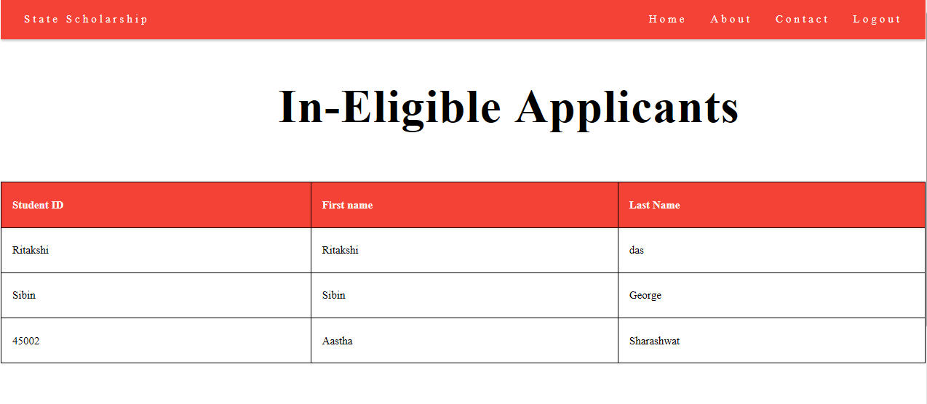

* Home – Redirects back to Admin Home page.
* About – Redirect to Info about scholarship website.
* Contact – Redirect to contact details.
* Logout – It expires student login session and brings him back to Admin login page.
* In-eligible applicants – admin can view In-eligible students.



* About us.
* Home – Redirects back to Home page.
* About – Brings back the cursor to about scholarship.
* Contact – Redirect to contact details.

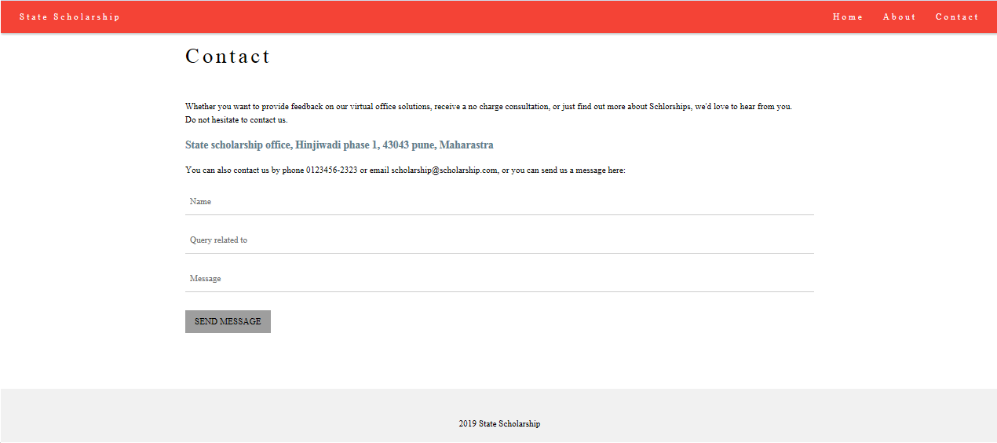

* Contact – Brings the cursor back to Contact.
* Home – Redirects back to Home page.
* About – Brings back the cursor to about scholarship.